Proxy using PAC file

# To get new IP addresses for the firewall.

Go to opmanager

Run Powershell as admin

Cd c:\temp

Run Ipaddresses

This will check to see if there are any new addresses and if there are it will display them.

These IP addresses will need adding to the firewall.

It will also display the urls for the proxy bypass.

But you can use the other powershell script to generate the proxy pac file for o365.

# To get urls for the PAC file

Opmanager

C:\temp

Office365ProxyPac.ps1

# To edit PAC file

Log onto Iwsva653

<http://iwsva653:1812>

Go to Pac file management

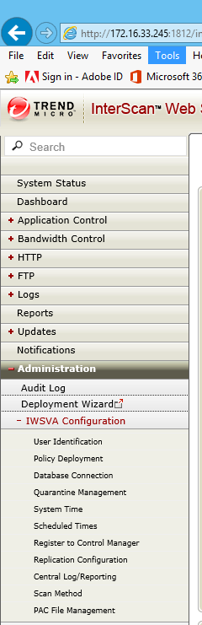

Pac file

<http://IWSVA653:1817/pac_files/Office365PAC.pac>

Click on the pac file

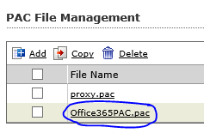

You can then edit the text.

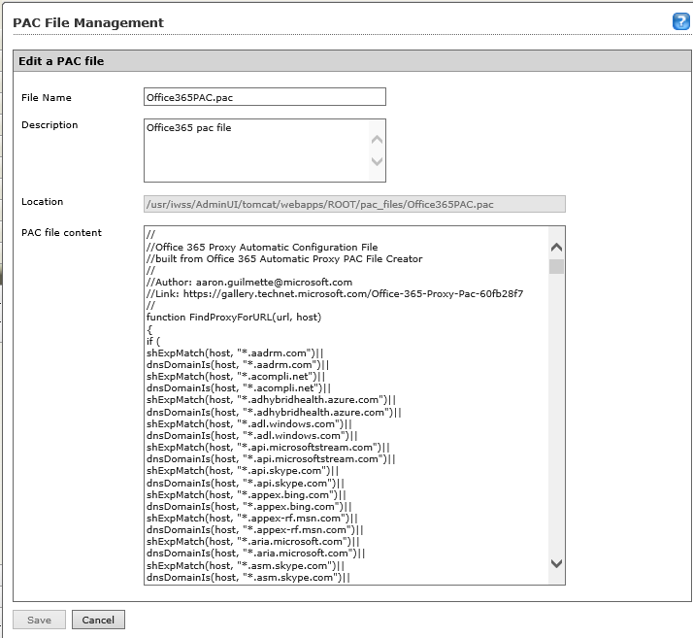

# Copy a line of existing and add the new url

dnsDomainIs(host, "www.youtube.com")||

dnsDomainIs(host, "xsi.outlook.com")||

shExpMatch(host, "zoom-cs-prod*.cloudapp.net")||

dnsDomainIs(host, "zoom-cs-prod*.cloudapp.net")||

dnsDomainIs(host, "ottouk.com")||

dnsDomainIs(host, "fgh-uk.com")||

dnsDomainIs(host, "office365.com")

)

return "DIRECT";

else { return "PROXY iwsslb.ottouk.com:8080; DIRECT";}

}

# Copy a line of existing IP address and add new IP address.

isInNet(host,"52.231.207.185","255.255.255.255")||

isInNet(host,"52.231.36.175","255.255.255.255")||

isInNet(host,"52.238.119.141","255.255.255.255")||

isInNet(host,"52.242.23.189","255.255.255.255")||

isInNet(host,"52.244.160.207","255.255.255.255")||

isInNet(ip, "127.0.0.0", "255.0.0.0") ||

isInNet(ip, "169.254.0.0", "255.255.0.0") ||

isInNet(ip, "10.0.0.0", "255.0.0.0") ||

isInNet(ip, "192.168.0.0", "255.255.0.0") ||

isInNet(ip, "172.16.0.0", "255.240.0.0")||

dnsDomainIs(host, "a.wunderlist.com")||

dnsDomainIs(host, "account.activedirectory.windowsazure.com")||

dnsDomainIs(host, "account.live.com")||

dnsDomainIs(host, "account.office.net")||

# Browser Settings

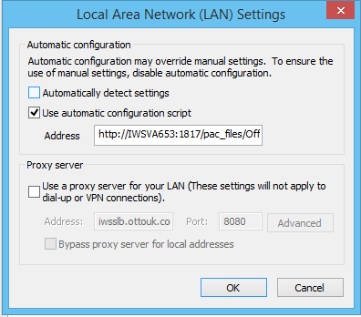

Group policy applied to Windows 10…